DIS-MEX-Mezcala-Figure-4 5-8 in

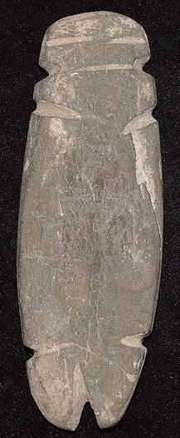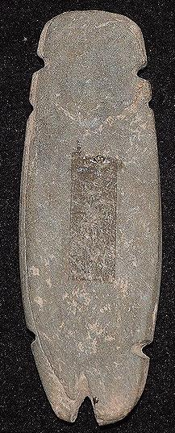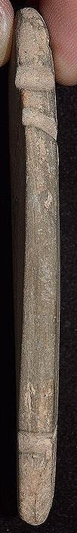

# Order details

## Sales order

Sold by [induringart](http://myworld.ebay.com/induringart) ( [1503](http://feedback.ebay.com/ws/eBayISAPI.dll?ViewFeedback&userid=induringart) )

### Delivery package 1 of 1

Estimated delivery Wednesday, Mar 30, 2016 - Wednesday, Apr 6, 2016

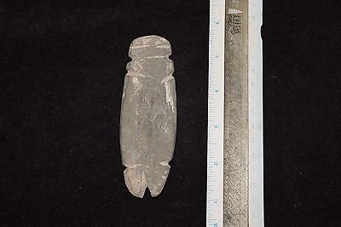

#### [Museum Quality pre columbian stone mezcala figure](http://www.ebay.com/itm/131757422172)

|  |  |
| --- | --- |
| Item price | $79.99 |
| Quantity | 1 |
| Item number | 131757422172 |
| Shipping service | Standard Shipping |

## Shipping address

Ralph J Coffman Jr

149 Atlantic Ave

Swampscott MA 01907-2427

United States

## Order total

|  |  |
| --- | --- |
| Subtotal | $79.99 |
| Shipping | $4.99 |

**Total**

$84.98

Order placed on

Wednesday, Mar 23, 2016

Payment method

PayPal

Payment date

Wednesday, Mar 23, 2016